|  |  |  |
| --- | --- | --- |
| f |  |  |
| **Benha University** |  | **Faculty of Computers & Artificial Intelligence** |

**Bank Management System**

**In**

Information System

**by**

Student’s Full Name (Student Section Number)

|  |  |
| --- | --- |
| عبدالرحمن كرم محمود(Section 10) | عبدالرحمن امجد عبداللطيف(Section 10) |
| عبدالرحمن محمد طلعت(Section 11) | عبدالرحمن رضا دارديري (Section 10) |
| ضحى ايمن هلال(Section 10) | علا يوسف جودة(Section 11) |

**Supervised by**

Dr.Shima Ismail

Eng.Ahmed Tawfik

# We have our Simple Bank System:

First thing first:

You go into a main page which you choose wethear you want to be employee or want to be client

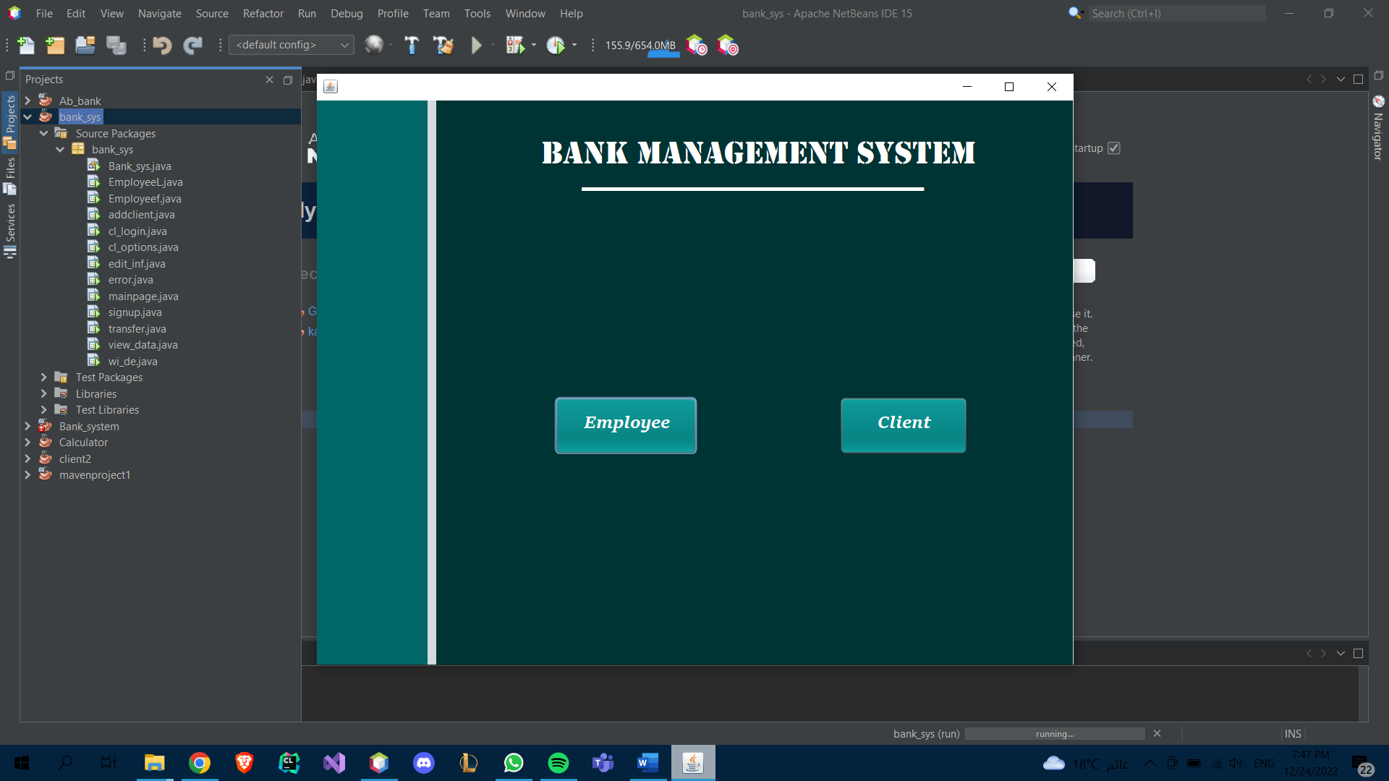

As an employee, you can signup and login but as a client you can only log in

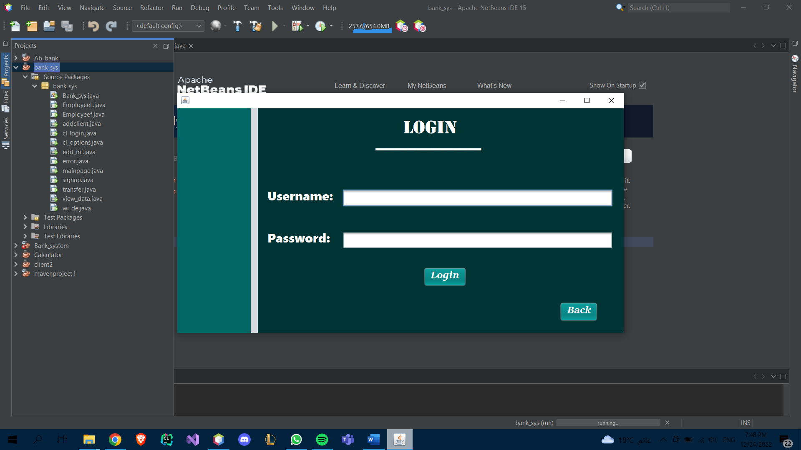

If a new client is added, his balance is initially 0.

A client can deposit money,withdrow,and review his info.

